Science Reviewer
Science of Materials
Science Investigations:
- Research – Research is a structured and in-depth study conducted to discover new information, verify existing knowledge or solve problems. It involves gathering data from various sources (such as experiments, surveys or literature), analyzing the information, and interpreting results to develop conclusions or new understanding.
- Focuses on testing scientific questions through experiments or observations
- Science Investigation – A science investigation is a systematic process used to explore, observe and test questions about the natural world. It involves identifying a problem, forming a hypothesis, conducting experiments or observations, collecting and analyzing data and drawing conclusions based on evidence.
- Broader process of systematically studying a topic to generate or validate knowledge.

Variables:
- Variables – In experiments and science investigations, variables are factors or conditions that can change or be changed. Understanding the different types of variables is important to ensure fair testing and accurate results.
- Independent Variable – The independent variable is the factor that the researcher intentionally changes or manipulates in an experiment to observe its effect.
- Example: amount of sunlight given to plants
- Description: It is the cause or input in an investigation.
- Dependent Variable – The dependent variable is the factor that is measured or observed as the result of changing the independent variable.
Example: height or growth rate of plants
Description: It is the effect or outcome of the investigation.
- Controlled Variables (Constant Variables) – Controlled variables are all the factors that are kept the same throughout the experiment to ensure that only the independent variable affects the results.
- Examples: type of soil, amount of water, plant species
- Description: They help make the experiment fair and reliable.
- Control Group – A control group is a group in an experiment that does not receive the independent variable or receives standard conditions.
- Example: plants that receive no added fertilizer
- Description: It is used for comparison to determine the effect of the independent variable.
- Experimental Group – The experimental group is the group that receives the independent variable.
- Example: plants given fertilizer
- Description: Results from this group are compared with the control group.
- Confounding Variables – Confounding variables are factors that unintentionally affect the results and can interfere with the relationship between the independent and dependent variables.
- Example: differences in temperature or light exposure
- Description: They can cause inaccurate conclusions if not controlled.

- Extraneous Variables – Extraneous variables are any additional variables that may influence the outcome of an experiment but are not the focus of the study.
- Description: If not controlled, they may become confounding variables.
- Responding Variable – The responding variable is another term for the dependent variable, emphasizing that it responds to changes in the independent variable.
- Summary:
- Independent – what you change
- Dependent or Responding – what you measure
- Controlled – what you keep the same
- Control Group – no treatment
- Experimental Group – receives treatment
- Confounding or Extraneous – unwanted influences

Research Design:
- Research Design – Research design is the overall plan or blueprint of a study that outlines how data will be collected, measured and analyzed to answer a research question or test a hypothesis. It ensures that the research is systematic, valid, reliable and efficient.
- Experimental Research Design – Involves manipulating an independent variable to observe its effect on a dependent variable while controlling other variables.
- Key Feature: Use of control and experimental groups
- Purpose: To determine cause-and-effect relationships
Example: Testing the effect of fertilizer on plant growth
- Quasi-Experimental Research Design – Similar to experimental design but lacks random assignment of participants.
Key Feature: Groups are pre-existing
- Purpose: To study cause-and-effect when full control is not possible
- Example: Comparing academic performance of two existing classes using different teaching methods
- Descriptive Research Design – Focuses on describing characteristics of a population or phenomenon without manipulating variables.
- Key Feature: Observation and data recording only
- Purpose: To answer “what is happening”
- Example: Surveying students’ study habits
- Correlational Research Design – Examines the relationship between two or more variables to determine if they are related.
- Key Feature: No manipulation of variables
- Purpose: To identify associations, not causation
- Example: Studying the relationship between screen time and academic performance
- Exploratory Research Design – Used when little is known about a topic and aims to gain initial insights.
- Key Feature: Flexible and open-ended methods
- Purpose: To develop research questions or hypotheses
- Example: Interviews about a new environmental issue
- Qualitative Research Design – Focuses on non-numerical data such as experiences, opinions, and behaviors.
- Key Feature: Interviews, focus groups, observation
- Purpose: To understand meanings and perspectives
- Example: Studying students’ attitudes toward online learning
- Quantitative Research Design – Uses numerical data and statistical analysis.
- Key Feature: Structured tools like tests and surveys
- Purpose: To measure variables and test hypotheses
- Example: Measuring test scores before and after an intervention
- Mixed-Methods Research Design – Combines qualitative and quantitative approaches in one study.
- Key Feature: Uses both numerical and descriptive data
- Purpose: To gain a more complete understanding of a research problem
- Example: Surveying students’ scores and interviewing them about learning experiences
- Case Study Research Design – An in-depth investigation of a single individual, group, or event.
- Key Feature: Detailed and contextual analysis
- Purpose: To explore complex issues in real-life settings
- Example: Studying the recovery of a specific ecosystem
- Summary:
- Experimental – cause and effect
- Quasi-experimental – limited control
- Descriptive – describes phenomena
- Correlational – examines relationships
- Exploratory – initial understanding
- Qualitative – meanings and experiences
- Quantitative – numerical measurement
- Mixed-methods – combined approach
- Case study – in-depth analysis

Chemical Bonds
Chemical Bonds:
- Chemical bonding – The force of attraction that holds atoms or ions together to form molecules and compounds. It occurs when atoms interact to lower their overall energy, making the resulting substance more stable than the separate atoms.
- Atom Bond – Achieve a stable electron arrangement, usually by filling their outermost (valence) shell – often following the octet rule (8 valence electrons), with some exceptions.
- Chemical Bonding – Explains how and why atoms combine to form substances, and the type of bond determines the properties of the matter formed
- Importance – Valence electrons determine an element’s physical properties (like melting point, conductivity, solubility), chemical behavior and reactivity, and explain the formation of molecules, compounds, and materials.

Valence Electrons:
- Valence Electron – The electrons located in the outermost energy level (shell) of an atom. These electrons are the ones involved in chemical bonding and determine how an atom reacts with other atoms.
- Description – Valence electrons are the outermost electrons of an atom, responsible for chemical reactions and bond formation, and their number influences an element’s reactivity, bonding type, and chemical properties.
- Role – Atoms gain, lose, or share valence electrons to achieve a stable electron configuration, where metals usually lose valence electrons to form positive ions and nonmetals usually gain or share valence electrons to form negative ions or covalent bonds.
- Valence Electrons and Periodic Table – For main-group elements, the number of valence electrons corresponds to the group number.

Electron Configuration:
- Electron Configuration – Is the arrangement of electrons in the energy levels, sublevels and orbitals of an atom. It shows how electrons are distributed around the nucleus and helps explain an element’s chemical behavior and properties.
- Description – Electrons occupy specific energy levels (shells) and sublevels (sharp, principal, diffuse, fundamental), each orbital holds up to two electrons with opposite spins, and they fill orbitals in order from lowest to highest energy levels.
- Principles:
- Aufbau Principle – Electrons fill atomic orbitals starting from the lowest energy level and move to higher energy levels only after the lower ones are filled; this helps predict the order of electron filling in electron configurations.
- Pauli Exclusion Principle – No two electrons in an atom can have the same set of four quantum numbers; an orbital can hold two electrons with opposite spins, explaining why electrons occupy different orbitals.
- Hund’s Rule – When electrons occupy orbitals of the same energy, they fill each orbital singly with parallel spins before pairing, which explains magnetic properties and the most stable electron arrangement.
- Summary:
- Aufbau Principle – Lowest-energy orbitals fill first.
- Pauli Exclusion Principle – Max of two electrons per orbital with opposite spins.
- Hund’s Rule – Electrons occupy equal-energy orbitals singly before pairing.
Subshell Symbol | No. of Orbitals in Subshell | Maximum No. of Electrons in Subshell
Sharp | 1 | $$1×2=2$$
Principal | 2 | $$3×2=6$$
Diffuse | 5 | $$5×2=10$$
Fundamental | 7 | $$7×2=14$$

Limits:  - s-orbital (sharp) – Can accommodate 2 electrons.  - p-orbital (principal) – Can accommodate 6 electrons.  - d-orbital (diffuse) – Can accommodate 10 electrons  - f-orbital (fundamental) – Can accommodate 14 electrons  Standard Notation:  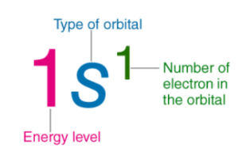 | 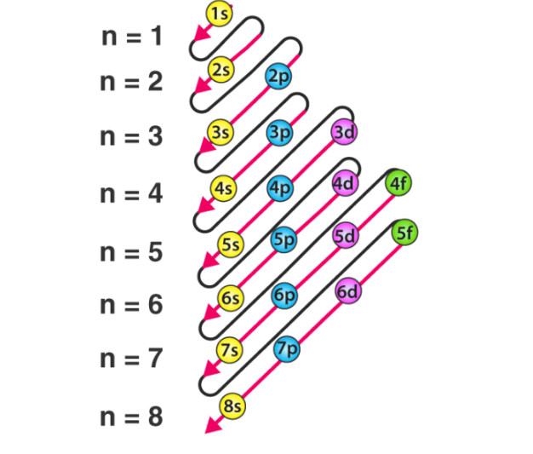

Octet Rule:
- Octet Rule – States that atoms tend to gain, lose or share electrons in order to have eight electrons in their outermost (valence) shell, which makes them more stable. This stable arrangement is similar to that of noble gases.
- Importance – Valence electrons help predict bond formation and chemical reactivity, explain the formation of stable ions and molecules, and serve as a basic model for understanding chemical bonding.
- Exceptions:
- Hydrogen and Helium – Are stable with 2 electrons (duet rule)
- Expanded Octet – Elements in period 3 and beyond can have more than 8 valence electrons.
- Incomplete Octet – Some atoms are stable with fewer than 8 electrons.

Lewis Structure:
- Lewis Structure – A Lewis structure is a diagram that shows the arrangement of valence electrons in a molecule or ion. It uses dots to represent valence electrons and lines to represent shared pairs of electrons (covalent bonds). Lewis structures help visualize bonding, lone pairs and molecular stability.
- Importance - Predicts bonding patterns, helps understand molecular geometry and polarity, and explains reactivity and stability of molecules.
- Atoms in a molecule, valence electrons as dots, covalent bonds as lines (each line = 1 shared pair of electrons), and lone pairs (nonbonding electrons).
- Steps in Drawing a Lewis Structure:
- Count the total number of valence electrons – Add valence electrons of all atoms. For ions, add electrons for negative charge or subtract electrons for positive charge.
- Choose the central atom – Usually the least electronegative atom. Hydrogen and halogens are usually terminal atoms.
- Connect atoms with single bonds – Draw single lines between the central atom and surrounding atoms. Each single bond represents 2 electrons.
- Distribute remaining electrons – Complete the octet of surrounding atoms first. Place leftover electrons on the central atom as lone pairs.
- Check the octet rule – If the central atom does not have an octet, form double or triple bonds by converting lone pairs into shared pairs.
- Check formal charges – Choose the structure with the lowest formal charges and place negative charges on more electronegative atoms.
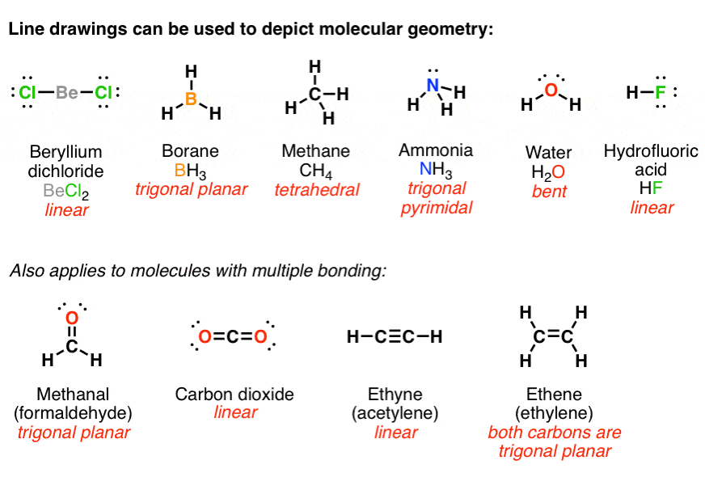

Molecular Geometry:
- Molecular Geometry – Refers to the three-dimensional shape of a molecule, describing how atoms are arranged in space around a central atom. It is determined by the repulsion between electron pairs (bonding and lone pairs) in the valence shell.
- Importance – Determine molecular polarity, affects physical and chemical properties, and influences biological activity and chemical reactions.
- Factors:
- Number of bonding pairs (shared electrons)
- Number of lone pairs (nonbonding electrons)
- Relative repulsion strength
- Lone Pair – lone pair > lone pair-bonding pair > bonding pair-bonding pair
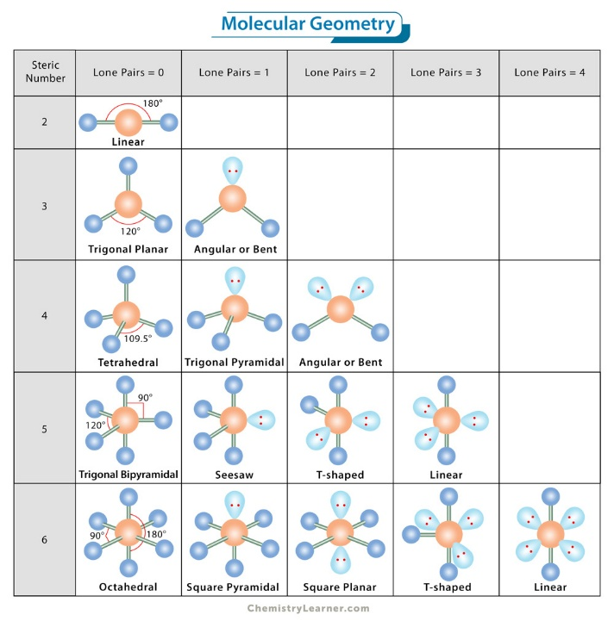 | 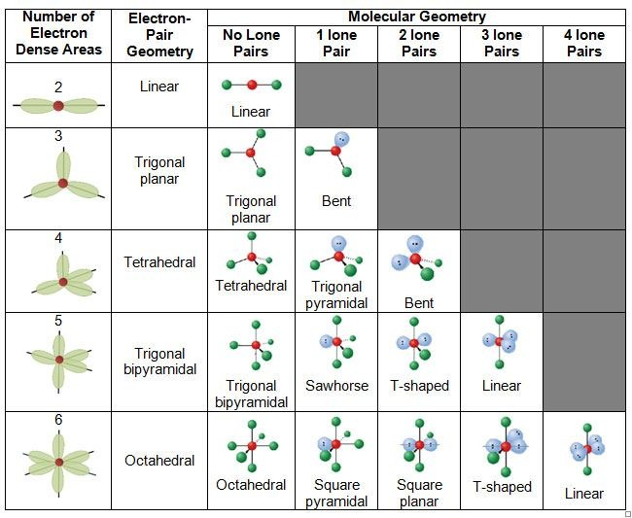

Chemical Reactions:
- Chemical Reactions – Chemical reactions are processes in which one or more substances, called reactants, are transformed into new substances, called products, through the breaking and forming of chemical bonds. During a chemical reaction, atoms are rearranged, but they are not created or destroyed, in accordance with the law of conservation of mass.
- Descriptions – Chemical reactions involve changes at the molecular or atomic level, where reactants interact through collisions to break and form bonds, producing products with different chemical and physical properties, and energy is released (exothermic) or absorbed (endothermic).
- Exothermic Reactions – Release energy (heat/light/sound), warming surroundings.
- Endothermic Reactions – Absorb energy from surroundings, making them feel cold.
- Characteristics – Formation of new substances with distinct properties, rearrangement of atoms without changing their total number, energy change (heat, light, electricity, or sound may be produced or absorbed), and observable signs like color change, gas formation, precipitate formation, or temperature change.
- Types of Chemical Reactions:
- Combination (Synthesis) Reaction – A combination reaction is a type of chemical reaction where two or more simple substances combine to form a single compound, resulting in one product and is common in the formation of compounds.
- General Equation: A + B = AB
- Decomposition Reaction – A decomposition reaction is a type of chemical reaction where a single compound breaks down into two or more simpler substances, often requiring energy such as heat, light, or electricity, and is the opposite of combination reactions.
General Equation: $AB = A + B$
- Single Displacement (Replacement) Reaction – A single displacement reaction is a type of chemical reaction where one element replaces another element in a compound, occurring when one element is more reactive than the other and is common in metal reactions with acids.
- General Equation: $A + BC = AC + B$
- Double Displacement (Replacement) Reaction – A double displacement reaction is a type of chemical reaction where ions in two compounds exchange partners to form two new compounds, often occurring in aqueous solutions and may form a precipitate, gas, or water.
- General Equation: $AB + CD = AD + CB$
- Combustion Reaction – A combustion reaction is a type of chemical reaction where a substance reacts rapidly with oxygen, producing energy in the form of heat and light, usually involving hydrocarbons and serving as an important source of energy.
- General Equation: $fuel + O₂ → CO₂ + H₂O + energy$
- Acid-Base (Neutralization) Reaction – An acid-base reaction is a type of chemical reaction where an acid reacts with a base to produce salt and water, involving the transfer of protons (H⁺) and reducing acidity or basicity.
- Redox (Oxidation-Reduction) Reaction – A redox reaction is a type of chemical reaction involving the transfer of electrons between substances oxidation is the loss of electrons and reduction is the gain of electrons, and it occurs in many reaction types such as combustion and displacement reactions.
- Oxidation: loss of electrons
- Reduction: gain of electrons
- Occurs in many reaction types (combustion, displacement)

Periodic Table

Classifications in the Periodic Table:
- Metalloids - These have the intermediate properties of metals and non-metals. These form a zigzag in the periodic table. They are boron, silicon, germanium, arsenic, antimony, tellurium, and polonium.
- Metallic Elements – They are found on the left side and the lower parts of the periodic table.
- Non-Metals - They are placed on the upper right part of the periodic table.

Symbols of the Periodic Table:
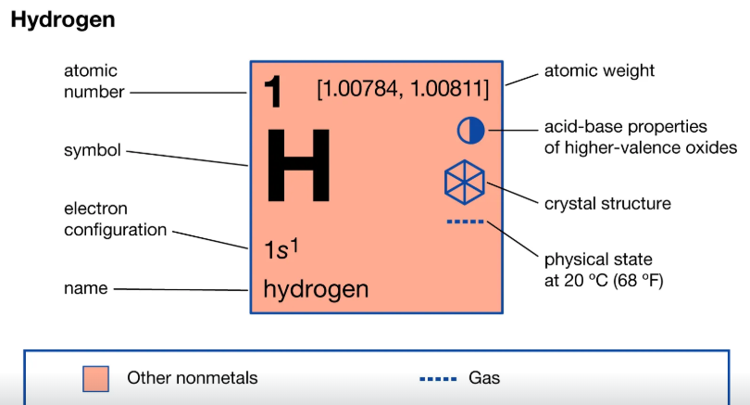
Groups and Periods:
- Groups – Is a column in a periodic table
- Periods – Is a row in a periodic table
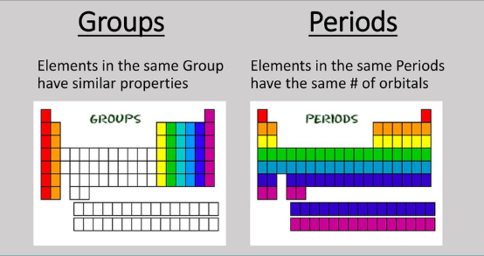
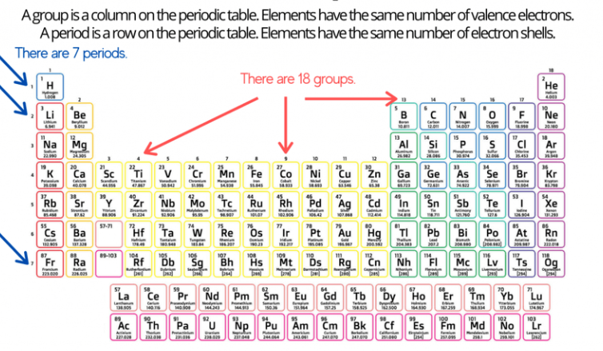

Groups in the Periodic Table:
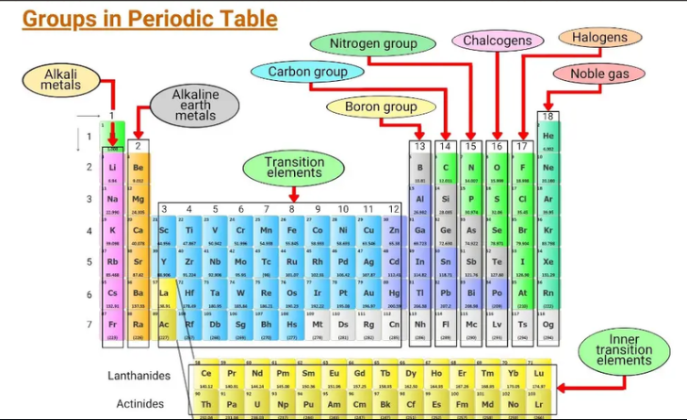
Group Number and Valence Electrons:
IUPAC Numbering Scheme | Old Notation (US) Scheme | Name of the Family | Number of Valence Electrons
1 | IA | Alkali Metals | 1
2 | IIA | Alkaline Earth Metals | 2
13 | IIIA | Boron Group | 3
14 | IVA | Carbon Group | 4
15 | VA | Nitrogen Group | 5
16 | VIA | Chalcogens | 6
17 | VIIA | Halogens | 7
18 | VIIIA | Noble or Inert Gases | 8

